Paper Title (use style: paper title)

line 1: 1st Given Name Surname
line 2: dept. name of organization
(of Affiliation)
line 3: name of organization
(of Affiliation)
line 4: City, Country
line 5: email address
line 1: 4th Given Name Surname
line 2: dept. name of organization
(of Affiliation)
line 3: name of organization
(of Affiliation)
line 4: City, Country
line 5: email address
line 1: 2nd Given Name Surname
line 2: dept. name of organization
(of Affiliation)
line 3: name of organization
(of Affiliation)
line 4: City, Country
line 5: email address
line 1: 5th Given Name Surname
line 2: dept. name of organization
(of Affiliation)
line 3: name of organization
(of Affiliation)
line 4: City, Country
line 5: email address
line 1: 3rd Given Name Surname
line 2: dept. name of organization
(of Affiliation)
line 3: name of organization
(of Affiliation)
line 4: City, Country
line 5: email address

Abstract—Give a concise summary (less than 3000 characters) of the paper: research focus, research methods used, the results and the main conclusions and recommendations. Use this document as a template if necessary or follow the instructions below to compose your manuscript. This electronic document is a “live” template and already defines the components of your paper [title, text, heads, etc.] in its style sheet. *CRITICAL: Do Not Use Symbols, Special Characters, Footnotes, or Math in Paper Title or Abstract.
Keywords— Choose up to four key words or phrases and locate them in alphabetical order just after the abstract of your paper, separated by commas.

Introduction
This document provides instructions for preparing manuscripts for publishing in the Conference Proceedings “Environment. Technology. Resources” at Rezekne Academy of Technologies. The document is also a sample of layout for the manuscripts submitted for publication.
The copyright of articles is transferred to the Rezekne Academy of Technologies. Articles will be published under Creative Commons Attribution 4.0 International License.

General Regulations
The structure of manuscripts:
- Abstract,
- Key words,
- Introduction,
- Materials and methods,
- Results and discussion,
- Conclusions,
- Acknowledgments,
- References.
The manuscript should be submitted to in an electronic format. Prepare the manuscript with Microsoft Word. The recommended length of the manuscript is 4-7 pages limitations, including information about the authors, abstract and images. Write the text in two column layout. Left and right justify the columns. When writing the manuscript use Times New Roman font.
Use tables and figures to adjust column length. On the last page adjust the length of columns so that they are equal. Use hyphenation only if it is necessary. Use Spell check. The Roman numerals used to number the sections are optional. If you do use them, do not number Acknowledgment and References, and arrange subheadings with letters.

A. Authors and Affiliations
Can have no more than 5 authors. Author names should be listed starting from left to right and then moving down to the next line. This is the author sequence that will be used in future citations and by indexing services. Names should not be listed in columns nor group by affiliation. Please keep your affiliations as succinct as possible (for example, do not differentiate among departments of the same organization).
For papers with less than five authors: To change the default, adjust the template as follows.
a) Selection: Highlight all author and affiliation lines.
b) Change number of columns: Select the Columns icon from the MS Word Standard toolbar and then select the correct number of columns from the selection palette.
c) Deletion: Delete the author and affiliation lines for the extra authors.

Figures, Tables and Equations
Preferable options for graphic images and photographs are: 300 dpi resolution, 8 bits per pixel, grayscale.
It must be noted that all the papers will be printed using grayscale printing technology.
Place figures and tables at the top and bottom of columns. Avoid placing them in the middle of columns. Large figures and tables may span across both columns. Figure captions should be below the figures; table heads should appear above the tables. Insert figures and tables after they are cited in the text. Use the abbreviation “Fig. 1”, even at the beginning of a sentence.
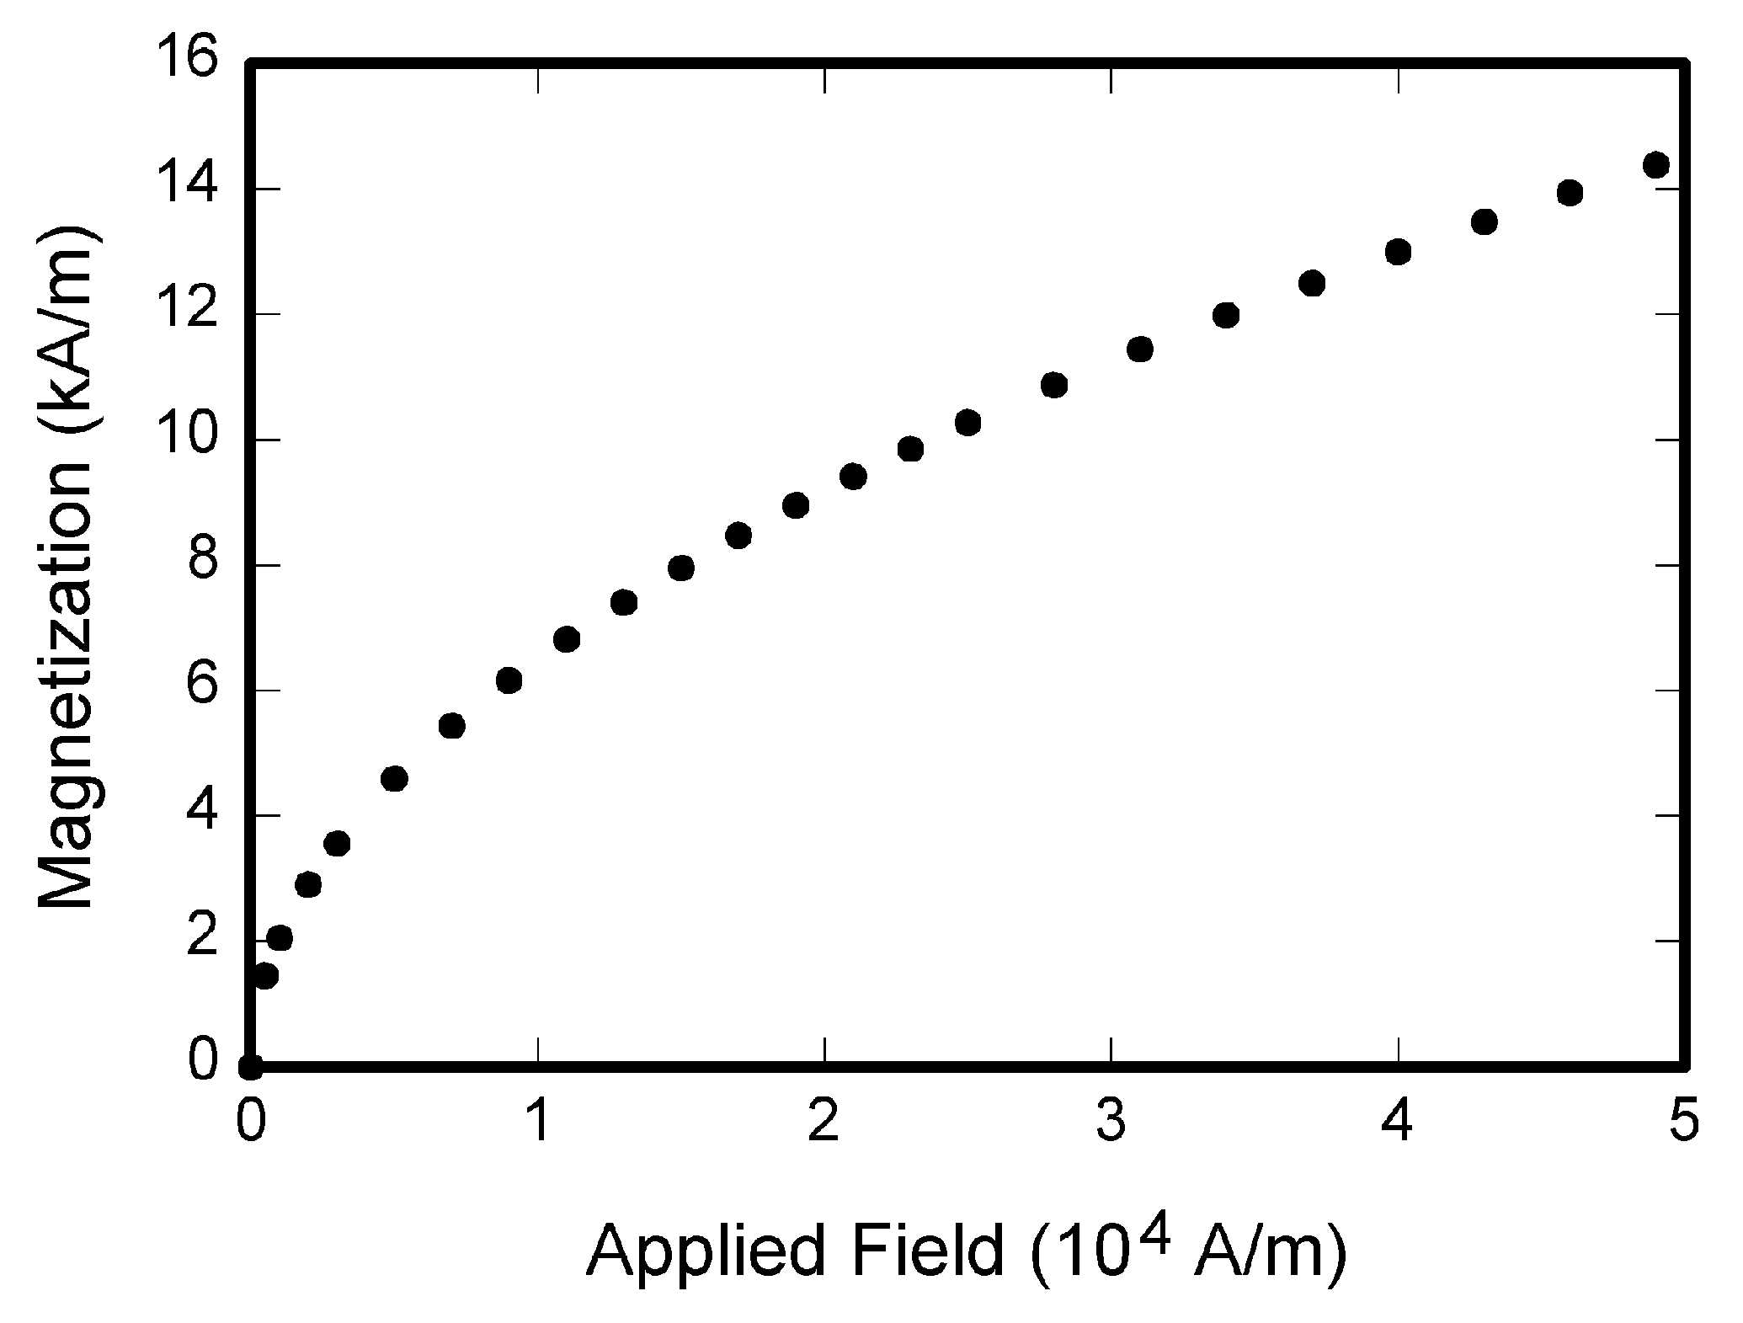
- Magnetization as a function of applied field.
If your figure has two parts, incorporate the labels “(a)” and “(b)” in the figure. At the same time, do not incorporate captions in the figures. Do not put captions in “text boxes” linked to the figures. Do not put borders around the outside of your figures. Use the abbreviation “Fig. 1” even at the beginning of a sentence.
Table captions and titles should always be right aligned and placed above the tables. Tables are numbered consecutively with Roman numerals and have reference in the main text.

Table 1 Type Styles
Table Head | Table Column Head
 | Table column subhead | Subhead | Subhead
copy | More table copy

Use the equation editor to create your equations. Place one tab before short equations to center them and one or two tabs after the equations to put equation’s number flush with the right margin, as in (1). Number the equations consecutively.
$c^{2}=a^{2}+b^{2}$          $ΔV_{C(0...T)}=\frac{1}{C}\int_{0}^{T}{i_{C}(t)dt}$               
The size of basic symbols in equations should correspond to the letter size of the main text (10pt). Use “(1)” not “Eq. (1)” or “equation (1)”.

Other Recomendations

Programs and Codes
If necessary, include parts or entire texts of your programs following the “Programs and Codes” style or using “New Courier” font. Try to fit such texts in one column.
void main(void)
{
WDTCTL = WDTPW + WDTHOLD; //Stop watchdog
P3DIR |= 0x01; //P3.0 - output
for (;;)
{ unsigned int i;
i = 50000;
do i--;while (i != 0); // Delay
P3OUT ^= 0xFF; } //Toggle P3.0
}
Wide programs may span across both columns.

Abbreviations and Acronyms
Define abbreviations and acronyms the first time they are used in the text, even after they have been defined in the abstract. Abbreviations such as IEEE, SI, MKS, CGS, sc, dc, and rms do not have to be defined. Do not use abbreviations in the title or heads unless they are unavoidable.

References
Follow IEEE reference requirements when preparing your list of references:
- https://ieee-dataport.org/sites/default/files/analysis/27/IEEE%20Citation%20Guidelines.pdf
- https://libguides.murdoch.edu.au/IEEE/home
Number the citations consecutively in square brackets [1]. The sentence punctuation follows the brackets [2]. Multiple references [2], [3] are each numbered with separate brackets [1] – [3]. In sentences, refer simply to the reference number, as in [3].
Please organise references in a successive manner throughout the paper, i.e., [1], [2], [3] and so on. If the article has a digital identification number (DOI), it is specified at the end of reference.
You must have your DOIs resolve to a page containing complete bibliographic information for the content with a link to—or information about—getting the full text of the content. You must include the DOI on the response page using Crossref DOI display guidelines, and use the DOI as the permanent link to the page.
Please following the samples provided at the end of this document for:
• A book with a single author [1], [2], with more than one author [3] and with three or more authors [4];
• Conference proceedings [5];
• Technical report [6];
• Patent/Standard [7];
• Papers presented at conferences (unpublished) [8];
• Thesis or dissertation [9];
• Chapters or parts of edited works included in collections or textbooks [10] - [11];
• Journal articles [12];
• E-Books [13] - [14];
• E-Journals [15] - [17];
• Internet documents [18] - [20];
• Non-book and other formats [21].
Papers that have been accepted for publication, but not yet specified for an issue should be cited as “to be published”. Papers that have been submitted for publication should be cited as “submitted for publication”. For papers published in translation journals, please give the English citation first, followed by the original language citation.
REFERENCES
- W.-K. Chen, Linear Networks and Systems. Belmont, CA: Wadsworth, 1993, pp. 123-135.
- S. M. Hemmington, Soft Science. Saskatoon: University of Saskatchewan Press, 1997.
- T. Jordan and P. A. Taylor, Hacktivism and Cyberwars: Rebels with a cause? London: Routledge, 2004.
- R. Hayes, G. Pisano, D. Upton, and S. Wheelwright, Operations, Strategy, and Technology: Pursuing the competitive edge. Hoboken, NJ: Wiley, 2005.
- T. J. van Weert and R. K. Munro, Eds., Informatics and the Digital Society: Social, ethical and cognitive issues: IFIP TC3/WG3.1&3.2 Open Conference on Social, Ethical and Cognitive Issues of Informatics and ICT, July 22-26, 2002, Dortmund, Germany. Boston: Kluwer Academic, 2003.
- K. E. Elliott and C.M. Greene, "A local adaptive protocol," Argonne National Laboratory, Argonne, France, Tech. Rep. 916-1010-BB, 1997.
- K. Kimura and A. Lipeles, "Fuzzy controller component," U. S. Patent 14,860,040, December 14, 1996.
- H. A. Nimr, "Defuzzification of the outputs of fuzzy controllers," presented at 5th International Conference on Fuzzy Systems, Cairo, Egypt, 1996.
- H. Zhang, "Delay-insensitive networks," M.S. thesis, University of Waterloo, Waterloo, ON, Canada, 1997.
- A. Rezi and M. Allam, "Techniques in array processing by means of transformations, " in Control and Dynamic Systems, Vol. 69, Multidemsional Systems, C. T. Leondes, Ed. San Diego: Academic Press, 1995, pp. 133-180.
- N. Osifchin and G. Vau, "Power considerations for the modernization of telecommunications in Central and Eastern European and former Soviet Union (CEE/FSU) countries," in Second International Telecommunications Energy Special Conference, 1997, pp. 9-16.
- E. P. Wigner, "Theory of traveling wave optical laser," Phys. Rev., vol. 134, pp. A635-A646, Dec. 1965.
- L. Bass, P. Clements, and R. Kazman. Software Architecture in Practice, 2nd ed. Reading, MA: Addison Wesley, 2003. [E-book] Available: Safari e-book.
- D. Ince, "Acoustic coupler," in A Dictionary of the Internet. Oxford: Oxford University Press, 2001. [Online]. Available: Oxford Reference Online, http://www.oxfordreference.com. [Accessed May 24, 2005].
- M. T. Kimour and D. Meslati, "Deriving objects from use cases in real-time embedded systems," Information and Software Technology, vol. 47, no. 8, p. 533, June 2005. [Abstract]. Available: ProQuest, http://www.umi.com/proquest/ [Accessed May 12, 2005] , https://doi.org/10.1016/j.infsof.2004.10.003
- H. K. Edwards and V. Sridhar, "Analysis of software requirements engineering exercises in a global virtual team setup," Journal of Global Information Management, vol. 13, no. 2, p. 21+, April-June 2005. [Online]. Available: Academic OneFile, http://find.galegroup.com. [Accessed May 31, 2005], https://doi.org/10.4018/jgim.2005040102
- A. Holub, "Is software engineering an oxymoron?" Software Development Times, p. 28+, March 2005. [Online]. Available: ProQuest, http://il.proquest.com. [Accessed May 23, 2005].
- European Telecommunications Standards Institute, “Digital Video Broadcasting (DVB): Implementation guidelines for DVB terrestrial services; transmission aspects,” European Telecommunications Standards Institute, ETSI TR-101-190, 1997. [Online]. Available: http://www.etsi.org. [Accessed: Aug. 17, 1998].
- G. Sussman, "Home page - Dr. Gerald Sussman," July 2002. [Online]. Available: http://www.comm.pdx.edu/faculty/Sussman/sussmanpage.htm [Accessed: Sept. 12, 2004].
- “A ‘layman’s’ explanation of Ultra Narrow Band technology,” Oct. 3, 2003. [Online]. Available: http://www.vmsk.org/Layman.pdf. [Accessed: Dec. 3, 2003].
- Thomson ISI, EndNote 7. [CD-ROM]. Berkeley, Ca.: ISI ResearchSoft, 2003.

Article templates contain guidance text for composing and formatting conference papers. Please ensure that all template text is removed from your conference paper prior to submission to the conference. Failure to remove template text from your paper may result in your paper not being published.

