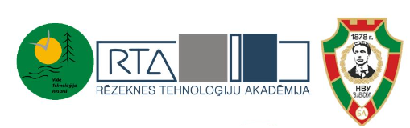

15th International Scientific Practical Conference

“Environment. Technology. Resources”

The conference is organized by Rezekne Academy of Technologies, Faculty of Engineering, Latvia

Hosted by ''Vasil Levski'' National Military University, Bulgaria

June 27, 2024 – June 28, 2024

Programme
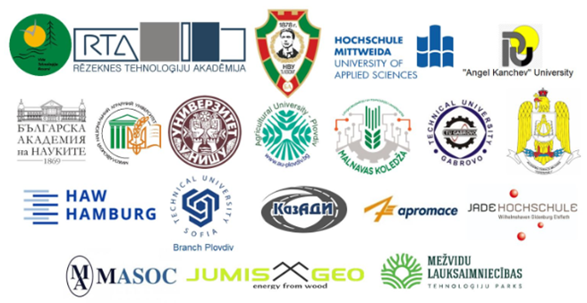

Rēzekne, 2024

Conference Programme 26.06.2024.

Time | Programme
 | ''Vasil Levski'' National Military University, Bulgaria
10.00-12.00 | VISIT to the production company
15.00-17.00 | CITY TOUR in Tsarevets. It is the residence of the Bulgarian kings in the 11th-14th centuries, when Tarnovo was the capital of Bulgaria
19.00 | CONCERT of the military orchestra of the National Military University "Vasil Levski" together with other orchestras
On June 24, the Veliko Tarnovo Medicinal Plant Festival takes place in Enevden, and if you arrive earlier, you can attend these events in the city.

Conference Programme 27.06.2024.

Time | Programme
''Vasil Levski'' National Military University, Bulgaria
Veliko Tarnovo
PO Box 5000, "Bulgaria" Blvd. Nr. 76
8.00-9.00 | Registration, coffee  1st floor hall
9.00- 9.20 | CONFERENCE OPENING  Room xxx
9.20-10.25 | PLENARY SESSION  Room xxx
10.40 – 12.30 | SECTIONS SESSION
 | Section 1 | Remote Section 2 | Remote Section 3 | Section 4
 | Room  xxx | Room  xxx | Room  Room xxx | Room  Room xxxx
12.30-13.30 | Coffee break, 1st floor hall
13.30-15.00 | SECTIONS SESSION
 | Section 1 | Remote Section 2 | Remote Section 3 | Section 4
 | Room xxx | Room xxx | Room xxx | Room xxx
16.00 – 18.00 | CITY TOUR in Veliko Tarnovo
20.00-23.00 | DINNER at the Yantra restaurant, there will also be a projection of the Tsarevets light show - sound and light
23.30 | RETURN TO Veliko Tarnovo

Conference Programme 28.06.2024.

Time | PROGRAMME
''Vasil Levski'' National Military University, Bulgaria
Veliko Tarnovo
PO Box 5000, 76 Blvd. Bulgaria
9.00-10.00 | VISIT to ''Vasil Levski'' National Military University, Bulgaria
10.00-10.30 | Coffee, 1st floor hall
10.30 – 12.30 | Remote section 1 | Section 2 | Remote section 3 | Section 4 | Poster  Section 5
 | Room xxx | Room xxx | Room xxx | Room xxx | 1st floor hall
12.30-13.30 | Coffee break, 1st floor hall
13.30-16.00 | Remote section 1 | Section 2 | Remote section 3 | Section 4 | Poster  Section 5
 | Room xxx | Room xxx | Room xxx | Room xxx | 1st floor hall
16.00 | VISIT to ''Vasil Levski'' National Military University, Bulgaria

